RBA: A Semi-Automatic Tool for Generating Customised R2RML Mappings
Luís Eufrasio T. Neto¹, Vânia Maria P. Vidal¹, Marco A. Casanova², José Maria Monteiro¹
¹ Federal University of Ceará, Fortaleza, CE, Brazil
{vaniap.vidal, luis.eufrasio, jmmfilho}@gmail.com
² Department of Informatics – Pontifical Catholic University of Rio de Janeiro, RJ, Brazil
casanova@inf.puc-rio.br
Abstract. In this paper, we demonstrate RBA (R2RML By Assertion), to automatically generate customized R2RML mappings based on a set of semantic mappings that model the relationship between the relational database schema and a target ontology in RDF. The semantic mappings are specified by a set of correspondence assertions, which are simple to understand. Optionally, the triples resulting from the mapping can be published into a local endpoint SPARQL using an embedded D2RQ Server extension.
Keywords: Linked Data, RDB-to-RDF user interface, R2RML mappings.
- Introduction
The Linked Data initiative [2] promotes the publication of previously isolated databases as interlinked RDF triple sets, thereby creating a global scale data space, known as the Web of Data. However, the full potential of linked data depends on how easy it is to transform data stored in conventional, relational databases (RDB) into RDF triples. This process is often called RDB-to-RDF [12].
There are two main approaches for mapping RDB to RDF: direct mapping and customized mapping. The Direct mapping approach relies on automatic methods that derive ontology from a relational schema and transform data according to that schema. The customized mapping approach lets an expert create a mapping between the relational schema and an existing target ontology that is used to make the transformation into RDF. In this approach, the RDB-to-RDF process can be divided into two steps: mapping generation and mapping implementation. The mapping generation step results in a specification of how to represent RDB schema concepts in terms of RDF classes and properties in a target vocabulary of the designer’s choice. The mapping is conceptual and enables different implementation styles. For example, it can be used to materialize the RDF view or to offer virtual access through an interface that queries the underlying database.
In fact, quite a few tools that support customized mapping have been developed, such as Triplify [1], D2R Server [3, 4], and OpenLink Virtuoso [9, 10]. Early surveys of RDB-to-RDF tools [12, 14] pointed out that the tools typically adopt different and proprietary mapping languages for the mapping process and do not provide a way to easily generate customized mappings between a RDB schema and a given domain ontology.
Recently, the W3C RDB2RDF Working Group proposed a standard mapping language, called R2RML [8], to express RDB-to-RDF mappings. However, R2RML is somewhat difficult to use, which calls for the development of tools to support the definition and deployment of mappings using R2RML. In this demo, we will show RBA a tool to easy the task of generating customized R2RML mappings.
- Generating R2RML Mappings with RBA
In our approach, we use a three-level architecture for mapping RDB to RDF, which is depicted in Figure 1. The exported ontology (EO) models the RDF view exported by the data source. The vocabulary of the exported ontology is a subset of the target ontology vocabulary. The middle layer consists of a set of relational view schemas VS, where VS is a direct transformation for the exported ontology E. The views schemas in VS can be implemented as SQL views or R2RML views.
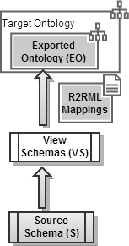  Fig. 1. Three Level Architecture | 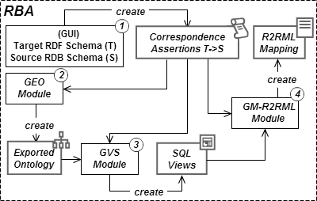  Fig. 2. RBA: main components
The benefits of using SQL views as a middle layer are twofold: (i) given that VS is a direct transformation of EO, the R2RML mapping between VS and EO can be automatically generated based on VS; (ii) it becomes easier to change the R2RML mapping M to accommodate changes to the database schemas.
Figure 2 highlights the main components of RBA. The process for generating R2RML mappings with RBA, consists of four steps:
STEP 1: A typical session with RBA starts with the user loading a source and a target schema into the system. Then, the user can draw correspondence assertions (CA) for specifying the mapping between the target RDF schema and the source relational schema. A correspondence assertion can be: (i) a class correspondence assertion (CCA), which matches a class and a relation schema; (ii) an object property correspondence assertion (OCA), which matches an object property with attributes or paths of a relation schema; or (iii) a datatype property correspondence assertion (DCA), which matches a datatype property with attributes or paths of a relation schema.
Figure 3 shows a snapshot of the GUI which is used for loading the schemas and entering the correspondence assertions. The source relational schema on the right, ISWC_REL, contains three tables: authors, papers and rel_author_paper. The Target Schema on the left, Conf_OWL (referencing well known vocabularies: foaf, dc and skos), contains three classes: foaf:Person, foaf:Document and skos:Concept. Using the ontology URI and database connection parameters typed by user, the application loads these two schema Trees. The user is able to create correspondences between the terms of the two schemas. The four lines drawn in Figure 3 represent (from Top Line to Bottom Line): one CCA to map relation authors to class foaf:Person with key attribute AuthorID composing the URI, one DCA to map attribute Email to data property foaf:mbox, another CCA to map relation papers to class foaf:Document with key attribute PaperID composing the URI and one OCA to map a path of foreign keys to object property dc:creator.
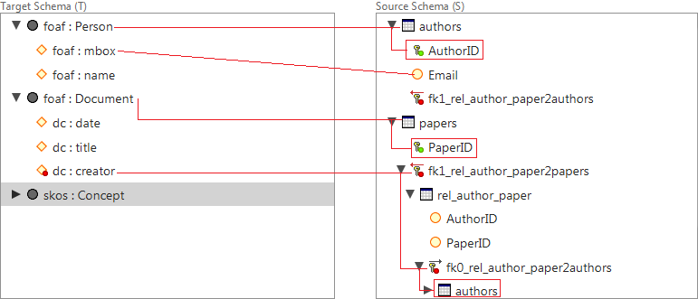
Fig. 3. Correspondence Assertions (CA) graphically represented
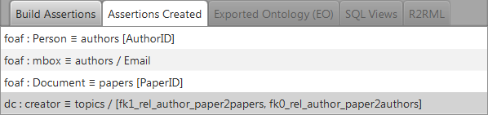
Fig. 4. Assertion Tab holds the list of assertions saved
We emphasizes the last CA, this OCA handles a heterogeneity problem between the two schemas. Object property dc:creator has foaf:Document as domain and foaf:Person as range, but there isn’t any foreign key that links relations papers and authors directly. Instead, there is a link relation rel_author_paper linking papers to authors. The OCA generated is a little complex, but user does not have to type it. He just clicks over the FK nodes in source Schema and RBA builds the text showed in line four of Figure 4.
STEP 2: The GEO (Gen Exported Ontology) module automatically generates the exported ontology based on the correspondence assertions defined in Step 1. This task is very simple, GEO traverses the list of Assertions Created and includes in EO all classes and properties mapped. Figure 5 shows the exported ontology for our case study. When user clicks over a node in EO Schema Tree, RBA shows the correspondent CA as showed in Figure 5.
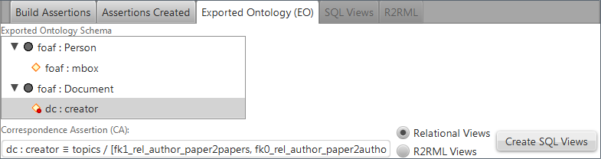
Fig. 5. Exported Ontology for our case study
STEP 3: The GVS (Gen Views Schema) module automatically generates the set of relational view schemas VS, where VS is a direct transformation for the exported ontology EO; The views schemas in VS can be implemented as SQL views or R2RML views and RBA allows the user to decide the kind of views will be created, see radio buttons in Figure 5. In [xx] we present an algorithm that automatically generates VS and the CAs between VS and E. Figure 5 shows the three SQL views generated for our case study:
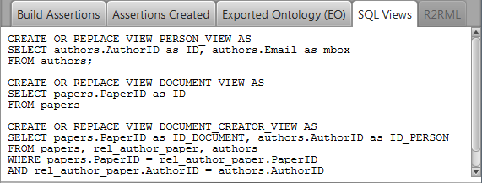
Fig. 6. SQL Views created
PERSON_VIEW implements two CAs: the CCA of class foaf:Person by selecting key attribute Author_ID renamed to ID to compose the URI and the DCA of datatype property foaf:mbox by selecting attribute Email which is renamed to mbox. DOCUMENT_VIEW implements the CCA of class foaf:Document by selecting key attribute Paper_ID renamed to ID to compose the URI. DOCUMENT_CREATOR_VIEW implements the OCA of object property dc:creator by creating joins linking relations authors, rel_author_paper and papers. These joins are created using the OCA’s path of FKs: [fk1_rel_author_paper2papers, fk0_rel_author_paper2authors].
STEP 4: The GM-R2RML module automatically generates a R2RML mapping M which maps VS to E. In [xx] we present an algorithm that automatically generates M from the the CAs between VS and E.

As the RDB-to-RDF mapping is done by the SQL Views, the resulting R2RML generated is trivial. It is showed in figure 7. Optionally, the user may request the publication of the relational data mapped and the tool will create an endpoint SPARQL based on the D2R extended component.
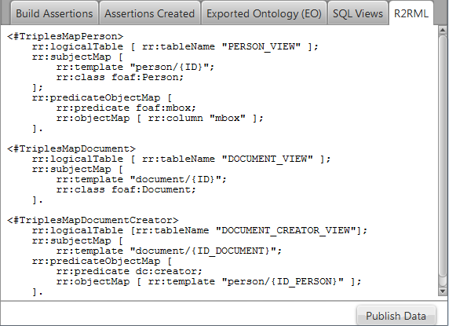
Fig. 7. R2RML mapping generated
References
- Auer, S., Dietzold, S., Lehmann, J., Hellmann, S., and Aumueller, D.: Triplify - Light-Weight Linked Data Publication from Relational Databases. In Proceedings of the 18th International World Wide Web Conference (2009).
- Berners-Lee, T: Linked Data, http://www.w3.org/DesignIssues/LinkedData.html (2006).
- Bizer, C., and Cyganiak, R.: D2R Server – Publishing Relational Databases on the Semantic Web, ISWC (2006).
- Bizer, C.: D2R Map – A Database to RDF Mapping Language, World Wide Web Conference (2003).
- Casanova, M. A., Breitman, K. K., Furtado A. L., Vidal, V. M., Macedo, J. A., Gomes, R. V., Salas, P. E.: The Role of Constraints in Linked Data. OTM Conferences (2) 2011: 781-799.
- Cerbah, F.: Learning highly structured semantic repositories from relational databases. The Semantic Web: Research and Applications pp. 777–781 (2008).
- Cullot,N.,Ghawi,R.,Ye ́tongnon,K.:DB2OWL:AToolforAutomaticDatabase-to-Ontology Mapping, pp. 491–494 (2007).
- Das, S., Sundara, S., and Cyganiak, R.: R2RML: RDB to RDF Mapping Language, W3C Working Draft, http://www.w3.org/TR/r2rml/ (2012).
- Erling,O.,Mikhailov,I.:Rdfsupportinthevirtuosodbms.NetworkedKnowledge-Networked Media pp. 7–24 (2009).
- OpenLink Virtuoso. http://virtuoso.openlinksw.com
- Polfliet, S., Ichise, R.: Automated mapping generation for converting databases into linked data. Proc. of ISWC2010.
- Sahoo, S.S., Halb, W., Hellmann, S., Idehen, K., Thibodeau Jr, T., Auer, S., Sequeda, J., Ez- zat, A.: A survey of current approaches for mapping of relational databases to rdf. W3C RDB2RDF Incubator Group report (2009).
- Sequeda, J.F., Depena, R., Miranker, D.P.: Ultrawrap: Using sql views for rdb2rdf. Proc. of ISWC2009.
- Sequeda, J., Tirmizi, S., Corcho, O., Miranker, D.: DMSurvey Survey of directly mapping SQL databases to the Semantic Web (2011).
- Vidal, V. M., Araujo, V. S., Casanova, M. A.: Towards Automatic Generation of Rules for Incremental Maintenance of XML Views of Relational Data. WISE 2005: 189-202.

